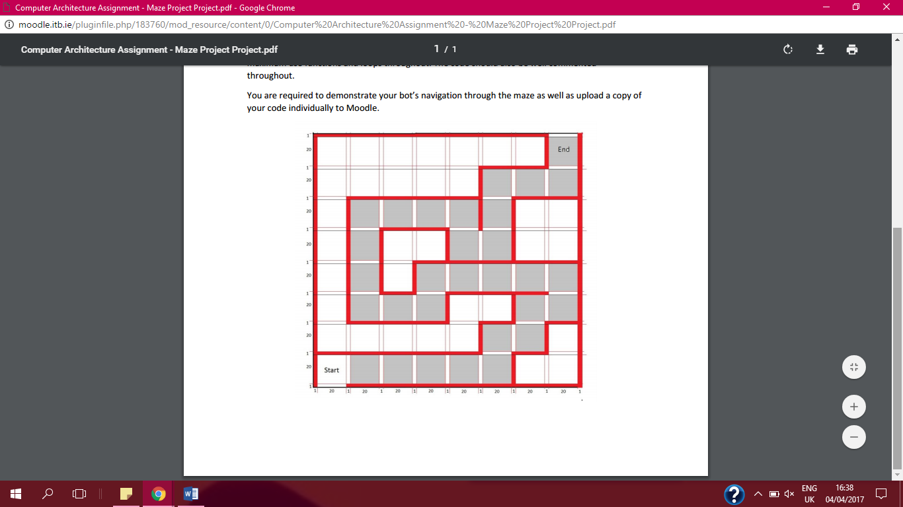

Part One

 Part Two

PART THREE

PART FOUR

PART FIVE

PART SIX



-Use the whiskers to detect the obstacles turns

-Encounter an obstacle-wall light up an LED and emit a bleep through the speaker

-IF: reverses emit a series of bleeps while reversing

SENSE MOVE SENSE

IF WHISKER LEFT, RIGHT SEPERATELY

TEST BY REV

DOESN’T SENSE STRAIGHT PATH FORWARD

MAZE BACKWARDS